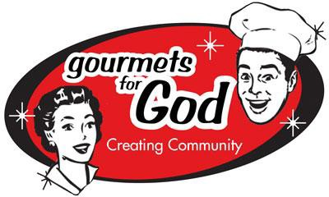
2022 EVENT HOST SUBMISSION FORM REGISTER YOUR EVENT TODAY!

Online Auction: Apr 22 -May 15 Onsite Auction: No Onsite
Available dates for events: May – December 31, 2022
As a Donation to CSL, the Sponsoring Host(s) & Chef(s) provide the food, drink, entertainment at their Event. All proceeds from G4G benefit the Center for Spiritual Living. Thank you!

This year, please consider open air/outdoor events during the warmer weather months.
Submit this form when your event plans are fully developed (no partial info please).
If you want to be matched with a home or cook/chef to put on an event, please note that in the space provided below.
PRINT CLEARLY

Event Title: (7 words or less)

Day: Date: / /2022

Time: am/pm - am/pm Number of Guests:

Description: (50 words maximum) (All event descriptions will be edited to fit this format.)

LEAD HOST: First Name Last Name

Co-Host Names: Chef(s) Name (s) :

Location: Address

City Zip Phone #

Email

Is this your first Gourmets event?  Would you like us to call you to answer any questions? 
Do you need to be matched with a chef? 

Skip questions if answer is No: Do you allow Smoking?  Inside Yes  Outside Yes
Is your event space ADA approved for wheelchair access?  Yes Special Diets supported  Yes Will pets be in the event space?  Yes Will there be alcohol at this event?  Yes
Is this an age 21 or over event?  Yes

Be a G4G Angel! I’d like to help someone with their event.  Yes
We’ll connect you with those who are looking for helpers.
* this can be helping in the kitchen, preparing, serving and/or clean up after the event.
SUBMIT YOUR FORM: via email at: Gourmets@SpiritualLiving.org
You will be contacted regarding your event submission to confirm date and details.

