Pastor Arnold Camacho
August 2-3, 2025
Message #15 / Matthew 6:25-34
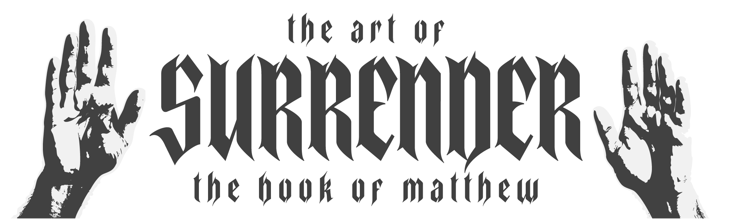
northcoastchurch.com/sermons

Surrender Your Worry

What is worry?

What does Jesus teach us in the midst of worry?
He teaches PERCEPTION.
Matthew 6:25-26, 28-30
He teaches the RESULT of worry.
Matthew 6:27, 30, 31, 32

He teaches what's TRUE of the FATHER.
Matthew 6:26-30, 32, Philippians 4:19, 1 Chronicles 29:11, Psalm 33:13, Psalm 34:15
He teaches the REPLACEMENT to worry.
Matthew 6:33-34

Practice HUMILITY.
1 Peter 5:6-7

RUN to Jesus.
Matthew 11:28-30

Keep the name of JESUS on your LIPS.
Matthew 28:18; Acts 4:12, John 14:13-14, Acts 3:6

Pastor Arnold Camacho
August 2-3, 2025
Message #15 / Matthew 6:25-34
northcoastchurch.com/sermons

Surrender Your Worry

What is worry?

What does Jesus teach us in the midst of worry?
He teaches ______________.
Matthew 6:25-26, 28-30

He teaches the __________ of worry.
Matthew 6:27, 30, 31, 32
He teaches what's ________ of the __________.
Matthew 6:26-30, 32, Philippians 4:19, 1 Chronicles 29:11, Psalm 33:13, Psalm 34:15
He teaches the _______________ to worry.
Matthew 6:33-34

Practice ____________.
1 Peter 5:6-7

_______ to Jesus.
Matthew 11:28-30

Keep the name of _________ on your ________.
Matthew 28:18; Acts 4:12, John 14:13-14, Acts 3:6

