Pastor Chris Brown
July 19-20, 2025
Message #13 / Matthew 6:1-18
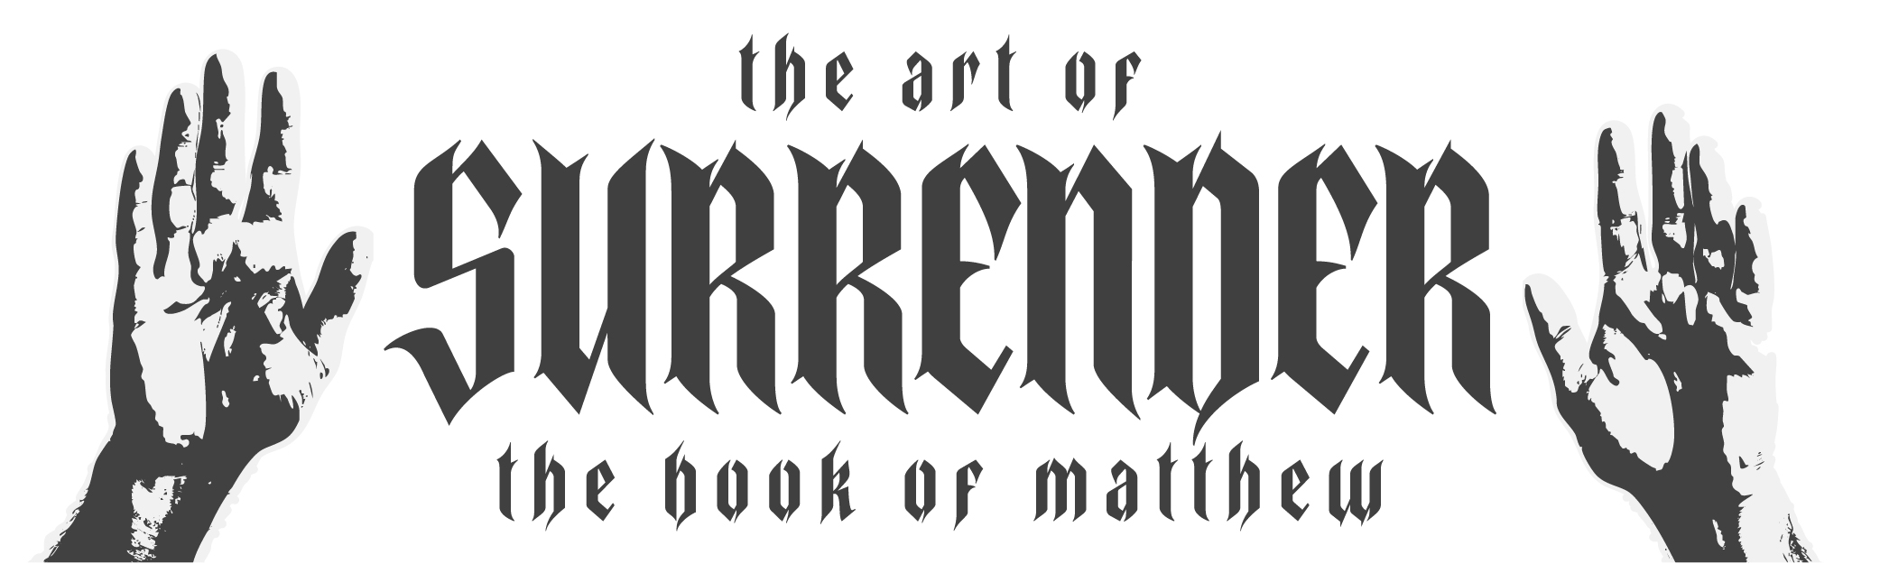
northcoastchurch.com/sermons

Was Jesus Really Against Religion?

Breaking bad religion from the inside out:
Matthew 6:1-18, Acts 5:1-8, 1 Samuel 16:7, Proverbs 4:23, Romans 15:26-27, 1 Corinthians 9:7-14
Relationship: John 3:3-18, Romans 6:23, 1 John 4:7-19, Ephesians 2:8-9, Romans 8:3, 1 Corinthians 6:19, Galatians 2:20

Jesus assumes His followers will be GIVING, PRAYING and FASTING.

Defining religion versus relationship:

Religion is checking off the RIGHT BOXES to get RIGHT with God.

Religious motives tend to make us LOOK BETTER and FEEL BETTER.

Relationship is a RESPONSE from the HEART because of how God CHECKED all the BOXES for us.

How a great example becomes a lousy prayer:
Matthew 6:5-15, James 4:2-3, 1 Thessalonians 5:16-18, Colossians 3:12-14

The Lord’s Prayer is a HOW, not a WHAT.

It is a PATTERN to follow, not a PRAYER to recite.

It is an example of how to:

CONNECT with God, not how to INFORM Him.

Get our HEARTS right, not our WORDS right.

Focus on whose WILL and AGENDA gets daily priority.

Pastor Chris Brown
July 19-20, 2025
Message #13 / Matthew 6:1-18
northcoastchurch.com/sermons

Was Jesus Really Against Religion?

Breaking bad religion from the inside out:
Matthew 6:1-18, Acts 5:1-8, 1 Samuel 16:7, Proverbs 4:23, Romans 15:26-27, 1 Corinthians 9:7-14
Relationship: John 3:3-18, Romans 6:23, 1 John 4:7-19, Ephesians 2:8-9, Romans 8:3, 1 Corinthians 6:19, Galatians 2:20

Jesus assumes His followers will be _________, _____________ and _____________.

Defining religion versus relationship:

Religion is checking off the _____________ to get _______ with God.

Religious motives tend to make us ___________________ and
___________________.

Relationship is a ________________ from the ________ because of how God ____________ all the __________ for us.

How a great example becomes a lousy prayer:
Matthew 6:5-15, James 4:2-3, 1 Thessalonians 5:16-18, Colossians 3:12-14

The Lord’s Prayer is a ______, not a ________.

It is a ___________ to follow, not a ___________ to recite.

It is an example of how to:

____________ with God, not how to ___________ Him.

Get our __________ right, not our _________ right.

Focus on whose ________ and ____________ gets daily priority.

