

Cat No. W2102

U-Blot® Prestained Protein Ladder (1.7-40kDa)

U-Blot® Prestained Protein Ladder (1.7-40kDa) contains six highly purified and prestained recombinant proteins ranging from 1.7 kDa to 40 kDa (1.7, 4.6, 10, 15, 25, and 40 kDa). Among these, the 40 kDa band is orange-red, and the 10 kDa band is green. This standard is suitable for use as a protein molecular weight marker in SDS-PAGE and Western ELISA applications.

Applications
This color-prestained protein molecular weight standard is prepared in 1x SDS-PAGE loading buffer and can be used directly without boiling, diluting or adding a reducing agent. Depending on the size of the loading well, typically 5-10 microliters of this color-prestained protein molecular weight standard are loaded each time (5-10 µL is sufficient for a 5x1.5 mm gel well). Very clear protein bands can be observed during electrophoresis, after electrophoresis, and after transfer.

Main Storage Buffer
- 62.5 mM Tris-HPO, pH7.5
- 2mM EDTA
- 2 % (W/) SDS
- 33 % (W/) Glycerol
- 5mM DTT
- 0.02% (V/v) proclin300
Storage and stability：Stable at -20℃ for 36 months ; 4℃ for 3 months; 25℃ for 4 weeks

Important Product Information
Migration pattern of U-Blot® Prestained Protein Ladder (1.7-40kDa): The apparent molecular weight (kDa) of each protein has been determined by calibration against unstained protein standards in various electrophoresis buffer systems.
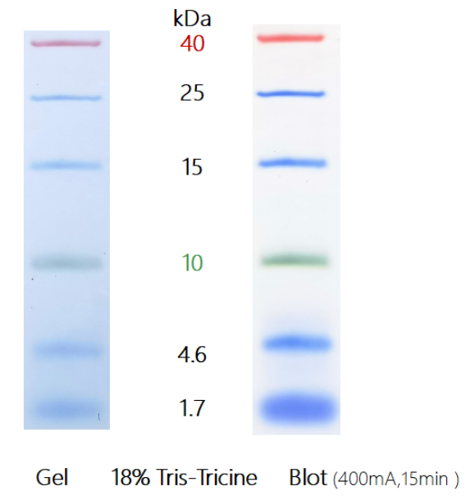

Instructions for use
- This product is ready-to-use. Before adding the sample, place it at room temperature for a few minutes to thaw, then gently shake to ensure the solution is evenly mixed. (Please do not boil, dilute, or add reducing agents.)
- Take 5 μL of the sample and load it into the gel wells for polyacrylamide gel electrophoresis ( if the well is wide, the sample volume can be increased accordingly ). It is recommended that
laboratories determine the appropriate sample volume through preliminary experiments based on their specific experimental conditions and preferences, especially when using this product for the first time, to save costs and achieve better experimental results.
- For frequent use, store at 2–8°C with a shelf life of 3 months. It is recommended to store in aliquots to avoid repeated thawing.

Tech notes
- Pay attention to the electrophoresis time; low molecular weight star proteins may migrate off the front of the protein gel.
- Be mindful of the specificity of small molecules when performing Western blotting, especially for bands smaller than 3 kDa, as they may pass through the membrane.
Additionally, it is recommended not to add SDS to the transfer buffer. If it must be used, the SDS concentration should not exceed 0.02-0.04%.
- Prestained proteins exhibit different apparent molecular weights in different buffer systems. If the buffer system is calibrated with non-prestained proteins beforehand, the protein molecular weight can be roughly determined.

