

Cat No. W2101

U-Blot® Prestained Protein Ladder（10-250 kDa）

U-Blot® Prestained Protein Ladder (10-250 kDa) contains a total of 9 kDa from 10 to 250 kDa highly purified and dye recombinant protein (10, 15, 25, 35, 55, 70, 100, 130, 250 kDa), among them 25 and 70 kDa The band is orange-red and 10 kDa is green.

Applications
It is suitable as the protein molecular weight standard for SDS-PAGE polyacrylamide gel electrophoresis and Western blotting. The molecular weight range from low to high can dynamically observe the electrophoresis state of the protein and clearly determine the molecular weight of the target protein. Meanwhile, after SDS-PAGE electrophoresis, clear colored bands can be seen when transferred to the PVDF membrane (or NC membrane), thereby monitoring the membrane transfer efficiency in the Western Blot experiment. The recommended dosage of this product is 5 to 10 μL.

Main Storage Buffer
- 20mM Tris-H₃PO₄ (pH7.5)
- 2mM EDTA
- 1.5% (W/V) SDS
- 15% (W/V) Glycerol
- 4M Urea
- 3mM DTT
- 0.1% (V/V) Proclin300
Storage and stability：Stable at -20℃ for 36 months ; 4℃ for 3 months; 25℃ for 4 weeks

Important Product Information
Migration pattern of U-Blot® Prestained Protein Ladder（10-250k Da）: The apparent molecular weight (kDa) of each protein has been determined by calibration against unstained protein standards in various electrophoresis buffer systems.
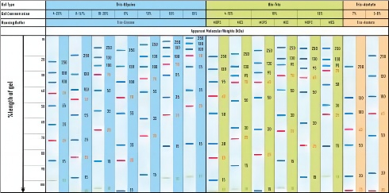
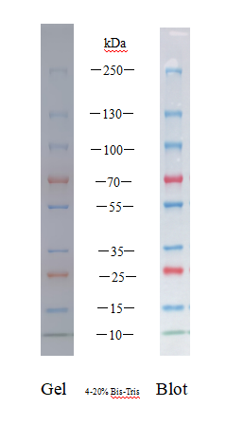

Instructions for use
- This product is a ready-to-use one. Before adding the sample, let

it stand at room temperature for several minutes to thaw, then gently shake it well to ensure the solution is evenly mixed. (Please do not boil, dilute or add a reducing agent for treatment! )
- Take 5 μl of the sample into the gel spotting well for polyacrylamide gel electrophoresis ( if the spotting well is wide, the sample loading amount can be appropriately increased ).
- It is recommended that laboratories with the necessary conditions determine the appropriate sample loading amount through pre-experiments when using this product for the first time based on their own experimental conditions and habits. This can save costs and obtain more effective experimental images at the same time.
- For frequent use, it can be stored at 2 to 8 degrees Celsius. The validity period is 3 months. It is recommended to aliquot and store it to avoid repeated freezing and thawing.

Tech notes
This product is convenient to package and can be used without heating, dilution or the use of other reducing agents.
- In Western blotting experiments, the large molecule proteins (100 kDa) in the product may require a longer transfer time or transfer current to complete the transfer. In addition, it is recommended that SDS be not added to the transfer membrane solution. If it must be used in the

experiment, it is suggested that the SDS concentration should not exceed 0.05%.
- The pre-stained protein bands have different migration rates after binding to the proteins in different SDS-PAGE buffers. In low- concentration gels (<10%), low-molecular-weight protein bands may migrate with the dye and are for reference only when used to determine the molecular weight of the target protein.
- It is recommended to use 12% separation gel or 4-20% gradient gel for electrophoresis.
- For your health, please wear a lab coat and disposable gloves when operating.

