Operation: Escape Planet Earth

Partners’ Names: ___________________________________________________

Our Topic is _______________________________________________________

FINAL PROJECT DUE: February 24th, 2026

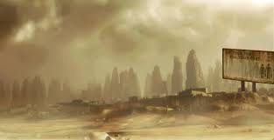

Somewhere in a galaxy not so far away…
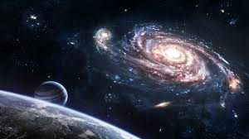
Although the Earthlings were warned of the impending doom that would result from their use of non-renewable resources, the climatologists’ cautionary messages were not heeded. Now Earth has become a barren wasteland. We have 2 weeks to evacuate the Earth before all resources are depleted and all of humanity perishes. You have been selected for a special operation team to plan the rescue and relocation plan for Earth’s people. You are charged with producing a proposal that will not only find a new home for the human race but explain how they will sustain life in the new location. You have an infinite amount of money and resources used for building space travel/stations.

Possible Destinations Include:
- Mercury
- Venus
- Luna, Earth’s moon
- Mars
- Jupiter
- Jupiter’s moons (Io, Calisto, Europa and Ganymede)
- Saturn
- Saturn’s moon Titan
- Uranus
- Neptune
- Pluto
- Planet X
- The Asteroid Belt
- The Kuiper Belt

Your proposal must include:
- Information about conditions on your planet/place. Be sure to answer ALL of the questions on the outline and include ALL of this information in your final RACER report.
- At least one drawing of your location or AI image of your planet.
- A list of the research sources you used. You must use at least 3 sources and include them in your bibliography.
- Any extra interesting information about your object that you think could convince someone to use your escape plan. For example:
  - Explain what you will do prevent future catastrophes on your place or planet.
  - Describe where or on what people will live.
  - Create a new way to travel there quickly.

Make your slides compelling, creative, artistic, and factual! After all, the future of Earth’s people is in your hands!
Due Dates
- Completed research outline: Due Monday, FEBRUARY 23RD.
- Final Proposal: Due TUESDAY, FEBRUARY 24th.

ALL OTHER WORK MUST BE COMPLETED ON YOUR OWN TIME!

Monday | Tuesday | Wednesday | Thursday
23  Research Outlines Due | 24  Research Outlines/ Group Presentation Begins | 25  Presentation of Project | 26  Presentation of Project

Group Presentation: Tuesday 24, 2026.

Solar System Research Outline
DUE TUESDAY February 24th, 2026

My Celestial body is _________________________________________________

How big is it? What is its diameter?
__________________________________________________________________________________________________________________________________________________________________________

What is its surface like? Is it rocky or gaseous?
__________________________________________________________________________________________________________________________________________________________________________

What is the climate like there? What are the average temps? Does this vary with day and night?
__________________________________________________________________________________________________________________________________________________________________________

Does it have an atmosphere? If so, what is the atmosphere made of?
__________________________________________________________________________________________________________________________________________________________________________

How long does it take to orbit the sun? What is the length of its year? (in Earth days or years)
__________________________________________________________________________________________________________________________________________________________________________

How long does it take to rotate? What is the length of its day? (in Earth hours or days)
__________________________________________________________________________________________________________________________________________________________________________

How will we be able to sustain life on this place / planet?
__________________________________________________________________________________________________________________________________________________________________________________________________________________________________________________________________________________________
If you need more room, take notes on a separate sheet of paper and attach it to this packet.
BIBLIOGRAPHY
You must use at least 3 sources. Write down their information here.
Books:
Title: __________________________________________________________________________________
Author(s): _____________________________________________________________________________

Title: __________________________________________________________________________________
Author(s): _____________________________________________________________________________

Websites:
www._________________________________________________________________________________

www.________________________________________________________________________________

www.________________________________________________________________________________
Formats for your Bibliography:
  - Fact sheet- GEMS ________ Fact Sheet. (ex: GEMS Jupiter Fact Sheet)
  - Super Teacher Worksheets Article- _________ by Cynthia Sherwood
(ex: Mars by Cynthia Sherwood)
  - Books- Title by Author (ex: Solar Systems by John Smith)
  - Websites- the URL for the website (http://www.nasa.gov/mission_pages/mars/main/)

Your Name: ________________________
Proposal RACER Rough Draft – Due Tuesday February 23rd, 2026
Prompt: Which place or planet should we relocate to and why?
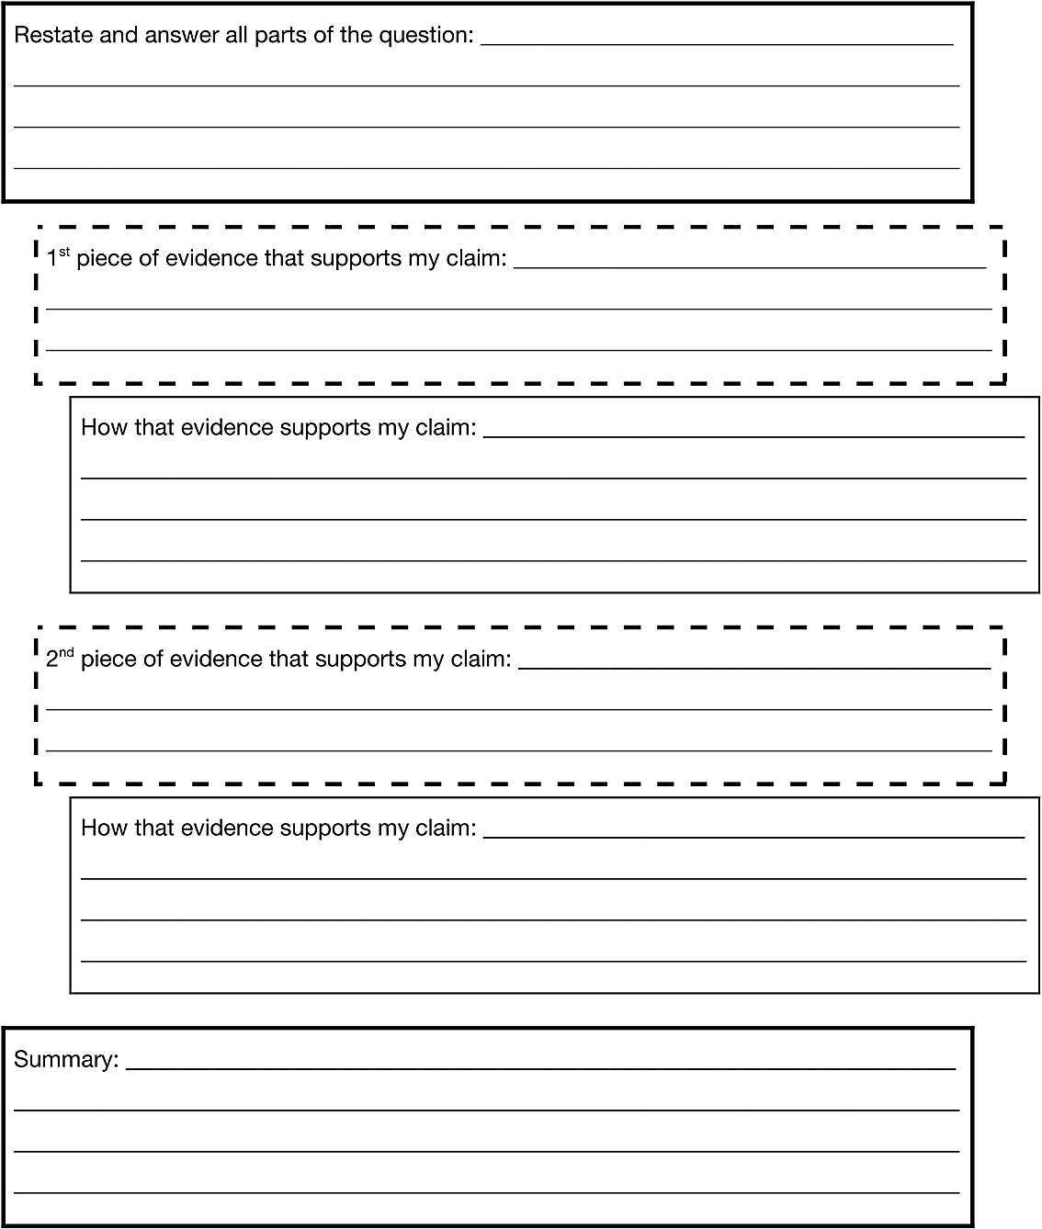

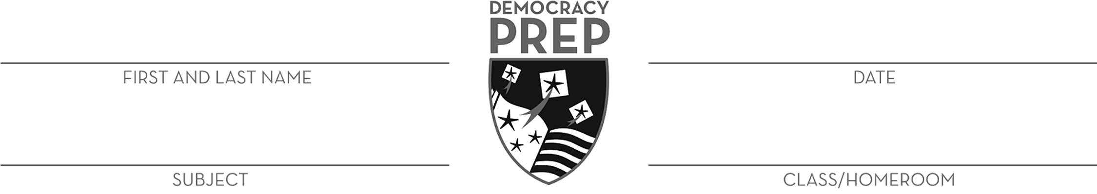
RACER Rubric
4 – Completely Correct | 3 – Mostly Correct | 2 – Partially Correct | 1 - Incomplete
Claim (RA)  ___ Scholar restates the question.  ___ Scholar’s claim answers all parts of the question.  Evidence (CER)  ___ Scholar’s 1st piece of evidence strongly supports the claim.  ___ Scholar completely explains how the 1st piece of evidence supports the claim.  ___ Scholar’s 2nd piece of evidence strongly supports the claim.  ___ Scholar completely explains how the 2nd piece of evidence supports the claim.  Structure  ___ Scholar completely summarizes the paragraph.  ___ Scholar uses appropriate science vocabulary.  ___ Scholar uses correct capitalization, spelling and grammar. | Claim (RA)  ___ Scholar restates the question.  ___ Scholar’s claim answers most parts of the question.  Evidence (CER)  ___ Scholar’s 1st piece of evidence mostly supports the claim.  ___ Scholar mostly explains how the 1st piece of evidence supports the claim.  ___ Scholar’s 2nd piece of evidence mostly supports the claim.  ___ Scholar mostly explains how the 2nd piece of evidence supports the claim.  Structure  ___ Scholar mostly summarizes the paragraph.  ___ Scholar uses appropriate science vocabulary.  ___ Scholar uses correct capitalization, spelling and grammar. | Claim (RA)  ___ Scholar restates the question.  ___ Scholar’s claim answers some parts of the question.  Evidence (CER)  ___ Scholar’s 1st piece of evidence partially supports the claim.  ___ Scholar’s explanation of the 1st piece of evidence is unclear.  ___ Scholar’s 2nd piece of evidence partially supports the claim.  ___ Scholar’s explanation of the 2nd piece of evidence is unclear.  Structure  ___ Scholar partially summarizes the paragraph.  ___ Scholar uses appropriate science vocabulary.  ___ Scholar uses correct capitalization, spelling and grammar. | Scholar’s answer is missing the following elements:  ___ Restated question  ___ Claim  ___ 1st piece of evidence  ___ 1st explanation  ___ 2nd piece of evidence  ___ 2nd explanation  ___ Summary  ___ Appropriate vocabulary

Scholar Name ___________________________

Research Outline Rubric
Points: | 0 | 1 | 2
Size  Is it bigger or smaller than Earth? | No size is included. | Size is included but inaccurate. | Correct size is included.
Surface type  Is it rocky or gaseous? | No surface type is included. | Surface type is included but inaccurate. | Correct surface type is included.
Climate  What is its average temperature? | No climate is included. | Climate is included but inaccurate. | Correct climate is included.
Atmosphere  Does it have one and if so, of what gases? | No atmosphere is included. | Atmosphere is included but inaccurate. | Correct atmosphere is included.
Length of Year  How long does it take to orbit the sun? | No length of year included. | Length of year is included but inaccurate. | Correct length of year is included.
Length of Day  How long does it take to revolve? | No length of day included. | Length of day is included but inaccurate. | Correct length of day is included.
Sustainability  How will you make life sustainable on this planet? | No sustainability plan included. | Sustainability plan lacks detail or explanation. | Sustainability seems plausible and is well explained.
 |  | Total Points: | /12

