SAN GABRIEL VALLEY TRIBUNE

Names & Faces - West Covina
Posted: 10/07/2010 10:38:19 AM PDT

Local boy is No. 1 6-year-old chess player in the nation
West Covina resident Joaquin Perkins has been named the No. 1-rated 6-year-old in the United States Chess Federation's October 2010 Top 100 rating list for age 7 and younger.
He is sixth on the list with 1447, also putting him at sixth among all players age 8 and younger.
Joaquin, a student at Oneonta Montessori School in Alhambra, learned to play chess at a very young age, learning first from his father, Kele, at home and at various local chess clubs and parks. He played in his first rated chess tournament at 3 years old.
In October 2009, he became the highest-rated 5-year-old in the United States with a tournament rating of 1180.
He went on to win the kindergarten category of the 2009 K-12 National Championship in Dallas, Texas, with a perfect 7-0 score.

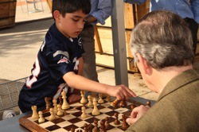
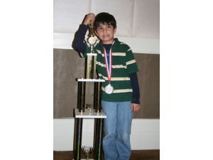
CONGRATULATIONS JOAQUIN

