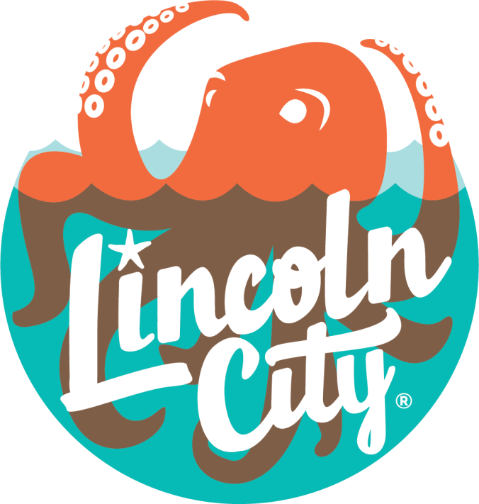

Explore Lincoln City
801 SW Hwy. 101, Suite 401
Lincoln City, OR 937367

REQUEST FOR PROPOSALS FOR “2023-2024 Expanded Market Outreach through Paid Media Project”

LINCOLN CITY, OREGON

Proposals Due: 5:00 PM, June 9, 2023

The City of Lincoln City through Explore Lincoln City is requesting proposals to use an expanded budget for the 2023-2024 Fiscal Year beginning on July 1, 2023 and ending on June 30, 2024 for a full multimedia mix outreach to Portland and Eugene areas through additional funding in its advertising and promotion budget. The available budget for this project will be $550,000 for paid media with a $20,000 contingency (opportunity fund). Explore Lincoln City is currently working with a marketing agency of record for a budget of $380,000 annually for net media until July 1, 2024. The purpose of this RFP is to seek proposals on how the additional $570,000 for paid media would be spent by marketing agencies to target expanded outreach on behalf of the City of Lincoln City.
Request for Proposals will be received by e-mail at ttrainor@lincolncity.org until 5:00 PM Pacific Standard Time (PST) on the 9th Day of June 2023.
All questions or requests for clarification shall be directed in writing to Tyrel Trainor, Financial Coordinator, Explore Lincoln City via email: ttrainor@lincolncity.org or by regular mail to Explore Lincoln City, 801 SW Highway 101, Suite 401, Lincoln City, Oregon 97367.
Review of submissions will occur during the month of June. Explore Lincoln City will work with the awarded agency to negotiate a contract or amended contract. Agencies will be notified should an interview need to be scheduled to provide additional details on submitted proposal.

Overview:
The City of Lincoln City has seen an increase in the Transient Room Tax that has allowed for additional funds for tourism. Explore Lincoln City believes that expanding advertising and promotion to targeted areas will bolster the economic health of Lincoln City, motivate overnight stays, and brand awareness. This project will meet the objective of growing Lincoln City’s marketing reach and market share.
The strategies would include:
- Presenting Lincoln City as a uniquely full of unexpected surprises through differentiated and eye-catching creative pieces.
- Drive overnight stays during the off-season (Fall, Winter, and Spring)
- Prioritize regional drive-market audience (Portland metro, Eugene)
- Identify events to be supported by paid media that will support overnight stays during the off-season.
- Use unconventional activations and sponsorships to reinforce brand, leverage media, and create deeper engagement with target markets.

Scope of Services and Deliverables:
The awarded agency would deliver Lincoln City as a place to visit through a number of media vehicles. The awarded agency would enhance the perceived value of Lincoln City, giving lodging properties, restaurants, and retail establishments, the ability to maximize profits and promote their improvements. Allowing for the expectation of ‘more to explore’ and valuable experiences with our guests. The agency would develop awareness of all experiences Lincoln City offers, and provide more opportunities to be seen as a weeklong vacation destination versus a weekend getaway.

Measurements:
The awarded agency would be measured for its channel-specific analytics, social listening, referral traffic, brand awareness, and followers.

Evaluation:
Proposals will be evaluated qualitatively based on the overall proposal, ability to meet the needs of Explore Lincoln City staff, ability to stay within the budget and experience working with destination organizations on the Oregon coast.

