THE GRIFFIN INVITATIONAL

Dear Colleagues,

Grossmont Community College Forensics Squad cordially invites you to attend the 18th Annual Griffin Invitational Speech & Debate Tournament to be held Saturday & Sunday, Nov. 20th & 21st, 2010 at Grossmont Community College.
Grossmont College is located, approximately 15 miles east of San Diego, in El Cajon, California.
Our college will also host the Ray Dahlin Individual Events Tournament, on Friday, Nov. 19th.

Our tournament offers your students:

- A One-Day Individual Events Tournament, on Saturday, Nov.20th with 3 rounds and finals in Open and Novice Divisions (if entries warrant). This allows your students to complete all their individual events in one day, including finals and awards. A separate Individual Events Awards ceremony will be held, and sweepstakes for the top three colleges will be awarded.

- Our "Picket Fence" Award: A special trophy for the student with a "picket fence" in individual events.

- A One-Day Parliamentary Debate Tournament, on Sunday, Nov.21st with Open, Junior and Novice Divisions (if entries warrant). We will be using the 4 preliminary rounds and 2 out rounds, model. There will be two out rounds, with first out round winners receiving bronze awards and second out round winners designated either silver or gold awards. (Open Division final round is negotiable) A separate Parliamentary Debate Awards ceremony will be held, and sweepstakes for the top three colleges in Debate will be awarded.
- An Overall Sweepstakes Award for the top three colleges in both Individual Events and Debate will be awarded during the final ceremony on Sunday.

- An experienced, conscientious, Tab room. The following tab room staff have worked together, some for most of the 18 years: Skip Rutledge: Point Loma U., Nancy Jennings: Cuyamaca C., Neil Moura: Mira Costa College, Danny Cantrell: Cerritos and Liana Koeppel: Cypress.

- Great food for the judges, so they won’t be too hungry to judge!

- A pleasant location: Grossmont is approximately 15 minutes from downtown San Diego, on the freeway, so you may even have time to visit some of San Diego's beautiful sights.

We look forward to seeing you at the Griffin Invitational Tournament, at Grossmont College.
Sincerely,

Roxanne Tuscany
Director of Forensics at Grossmont
619 644-7276(office), or 619 204-8792(cell)
roxanne.tuscany@gcccd.edu

Griffin Invitational 2010

Saturday Nov. 20th

Registration 7:30-8:30

8:30 Pattern A, Round 1 Extemp. Draw Rd.1, 8:15

9:45 Pattern B, Round 1

11:00 Pattern A, Round 2 Extemp. Draw Rd. 2, 10:45

12:30 Pattern B, Round 2

1:45 Pattern A, Round 3 Extemp. Draw Rd. 3, 1:30

3:00 Pattern B, Round 3

4:30 Finals Pattern A Extemp. Draw Finals Rd. 4:30
5:45 Finals Pattern B

7:15/ASAP Awards (Room 220)

PATTERN "A" Extemp, Informative, Poetry, Prose, STE
PATTERN "B" Impromptu, Duo, Persuasion, P.O.I., Drama, CA

Sunday Nov. 21st

Registration 8:30-9:00 Student Center

9:00 Topic Announce 1: Student Center
9:20 Round 1 Parli
10:30 Topic Announce 2
10:50 Round 2 Parli

12:15 Topic Announce 3
12:35 Round 3 Parli
1:50 Topic Announce 4
2:10 Round 4 Parli

3:25 Topic Announce Elim 1
3:45 Elim 1
5:00 Topic Announce Elim 2
5:20 Elim 2

7:00/ASAP: Awards in Room 220.

FEES & DEADLINES

ENTRY FEES:

$20.00 SCHOOL FEE :
$ 6.00 PER EACH I.E. SLOT
$12.00 PER DUO TEAM
$40.00 PER PARLI DEBATE TEAM

JUDGING FEES:

One I.E. judge covers five slots per pattern.
$ 15.00 PER UNCOVERED I.E. SLOT
One Parli Debate judge covers 2 debate teams.
$ 100.00 PER UNCOVERED DEBATE $100.00 (we need judges!)

We need your judges. Please do everything you can to bring judges!!

ENTRY DEADLINE: 7:00 p.m. on Wednesday, Nov. 17th.

Send your entry to: Forensicstournament.net

EVENTS AND RULES:

Individual Events:

11 individual events will be offered, in Open and Novice Divisions, if entries warrant.

PATTERN A: Extemporaneous PATTERN B: Impromptu Informative Persuasion
Poetry Interpretation Program Oral Interpretation
Prose Interpretation Drama Interpretation
Speech to Entertain Duo Interpretation
Communication Analysis

Individual Events Divisions: Novice and Open

Novice Division I.E.’s
A student who has not won a trophy (1st, 2nd, or 3rd Place) in an event in which a final round occurred. Students competing in an event which is similar; must be novice in all of those similar events. (Platform, Interp., Limited Prep). As an example; a student who is in Open Division in Prose, must also be open in Poetry, even if they have never competed in Poetry. Anyone who has won a Gold, Silver or Bronze at Phi Rho Pi is not a novice.

Open Division I.E’s
Any undergraduate in a two-year or four-year college may compete in open division.

- PLEASE NOTE: Individual Event competitors may enter 3 events per pattern,
except for those entered in Extemp. or Duo. Anyone entering 3 events per pattern, run the risk of missing a round and if you miss a round due to being triple entered you will forfeit that round.
- Extemper’s and Duo events may not triple enter.

- No material used in competition shall have been used by the student in intercollegiate competition prior to September 1, 2010.

“THE PICKET FENCE AWARD": The purpose of this award is to recognize a student who ranks first in all their preliminary and final rounds of competition in an individual event (6 first places). Traditionally, a student is recognized for this achievement by an announcement at the awards ceremony or by the individual's coach. The Griffin Speech Tournament awards this student with that recognition, as well as with a special "award".

Parliamentary Debate:

4 rounds of parliamentary debate will be offered with 2 out rounds. Bronze, Silver, and Gold will be awarded. Open, Junior & Novice divisions will be offered, if entries warrant

Parliamentary Debate Divisions: Novice, Junior and Open
NOVICE DIVISION PARLI
A team consisting of students in their first 2 semesters of competition (including high school or home school team policy, LD, Parli, Ted Turner, or other similar formats of debate), and neither team member has advanced to an out round twice. If either team member has competed in two out rounds, they must be advanced to Junior division. Eligibility violations will result in the removal of that team from the tournament.

JUNIOR DIVISION PARLI
Junior debaters may have up to 4 semesters of college debate and should not have advanced to more than two out rounds in Junior competition.

OPEN DIVISION
Open debaters are limited to students with 8 or fewer semesters of collegiate competition.

Any debater that has advanced to the elimination rounds at NPDA Nationals is considered an Open Division debater, regardless of the partner’s experience. Eligibility is determined based upon the most experienced partner.
A semester means the student has competed in three or more tournaments of any style of debate.

Parliamentary Debate Logistics:

Oral critiques immediately following the debate are discouraged, for time management reasons.
Please help us keep on schedule. Delays attributed to coach/judges, are at the tournament director’s discretion and may result in penalties to that school’s team (s), including automatic losses or even removal from the tournament.

Written materials may be used in preparation but not consulted in the competition room.
Coaching is allowed, however, it can only occur once the coach has secured their ballot for that
round and may not result in a delay of the commencement of the round.
It is illegal to reveal topic information prior to the topic being announced, even if it is printed on
The ballot.
The tournament will not offer warm room disclosure.

- Grossmont & Cuyamaca students may compete at the tournament. They will not be eligible for sweepstakes points or the "picket fence award".

Directions to Grossmont College
Address, Parking & Directions
Grossmont College
8800 Grossmont College Drive
El Cajon, CA 92020
From L.A. or other northern cities:

From I - 5 South, go to I - 805 South to 52 East. Stay on 52 East, which turns into the 125 South. Exit at Grossmont College Dr. Turn right into Grossmont College. Park in lots 5, which is the new parking structure . There should be no parking fees, or parking problems.

From I -15 South, go to 52 East. Follow directions above.

From the San Diego area, or directions from I-8 (airport):

From the West, take I - 8, East to Lake Murray Blvd.
Exit on Lake Murray Blvd. Stay on Lake Murray Blvd. going North.
Enter Grossmont College on Highwood Dr. and stay to the right. Use parking lots #5, which is the parking structure.

Note: This year the Student Center is under construction. We will be using other rooms for postings, Tab and Coaches lounge.

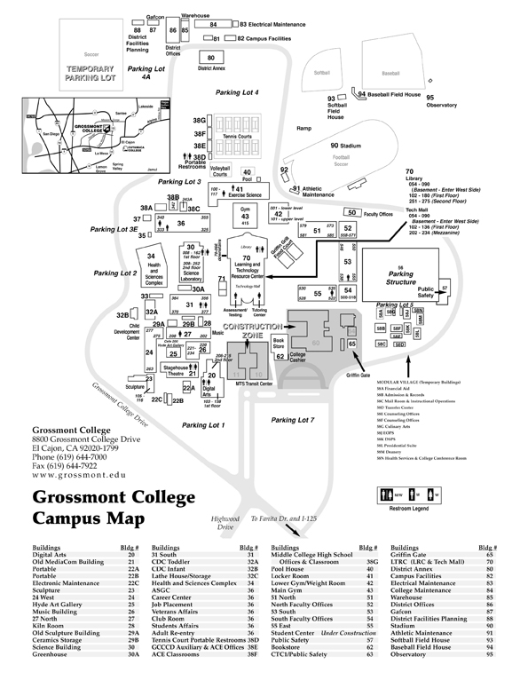

LODGING

We have a tournament hotel, this year. It is the Holiday Inn La Mesa. $99 +tax for 4 people/dbl beds. For the group rate, please ask for: Griffin Forensics Team.
There are many other options throughout the San Diego area.

TOURNAMENT HOTEL:

HOLIDAY INN La Mesa: $99 +tax for 4 people/dbl beds. Ask for: Griffin Forensics Team rate.
8800 Parkway Drive
La Mesa, CA 91942
619-698-7747
Restaurant on site, close to other restaurants and the Grossmont Center Mall.

Other hotels closest to the college:

HOLIDAY INN EXPRESS 619-466-0200
95550 Murray Drive
La Mesa, CA 91942
Complimentary Breakfast
Starting around $90.00 (when checked on-line)

TRAVELODGE LA MESA 619-466-5988
7911 University Ave.
La Mesa, CA 91941
Very low cost hotel. $59.00 (when checked on-line)

