**“The Heart of It All” Forensics Tournament**

**Hosted by John Carroll University**

**University Heights, Ohio**

**November 4, 2017**

**The Ohio Forensics Association is pleased to invite you to an open forensics tournament at John Carroll University on November 4. We will be offering twelve individual events including Radio Broadcasting. Awards will be presented to all finalists and the top three school sweepstakes winners.**

**You will be able to enjoy Ohio hospitality while you are here. We will be providing a lunch for all competitors. See below for details.**

**You may enter the tournament on Forensicstournament.net. The deadline for entries is Tuesday, October 31 at 5:00 p.m.**

**We look forward to seeing you in Ohio in “the heart of it all”.**

**Susan Millsap Brent Brossmann**

**President, OFA John Carroll University**

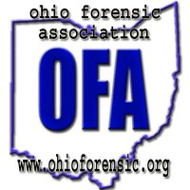

**Tournament Schedule**

**Saturday, Nov. 4**

**8:00 – Registration in lobby of the O’Malley Center**

**8:30 – Round 1 Bracket A and IPDA**

**9:45 – Round 2 Bracket A events and IPDA**

**11:00 – Extemp Draw and Broadcast Journalism prep**

**11:30 – Round 1 Bracket B events and**

**11:45 – Round 3 IPDA**

**12:00 – Sack lunches available**

**12:30 – Extemp Draw and Broadcast Journalism prep**

**1:00 – Round 2 Bracket B events and**

**1:20 – Round 4 IPDA**

**2:30 – Finals Bracket A**

**3:00 – Semi finals IPDA**

**3:45 – Extemp Draw**

**4:00 – Finals Bracket B**

**4:30 – Finals IPDA**

**6:00 – Awards**

**Bracket A Events:** Duo, Rhetorical Criticism, POI, Poetry, Persuasion, Impromptu

**Bracket B Events:** Extemp, Prose, Informative, After Dinner, Dramatic Interpretation, Radio Broadcasting

*[RAD] RADIO BROADCASTING*  
For each round, contestants receive a selection of media stories drawn from the past week and will have 30 minutes to prepare a 5 minute radio news broadcast. Notes are permissible and the speaker should perform seated, facing away from the judge. Contestants should include original call letters and transitional remarks.  The broadcast should be organized, clear, well-delivered and adhere to the time frame of the event.  Contestants are encouraged to time themselves. 5 minute maximum time limit.

**Entries:** Students may enter three events per bracket. Students may not enter both Extemp and Broadcast Journalism. IPDA debaters **cannot** enter Bracket A events. Please enter the tournament at [www.forensicstournament.net](http://www.forensicstournament.net) and please enter by **5:00 on Tuesday, October 31. Changes can be made with no penalty until 5:00 Wednesday. Late drops are $10 each. No charge for name changes.**

**Judges:** Please provide 1 judge for every 6 IE slots and 1 judge for every 2 debaters.

**Fees: $10.00 per IE slot and debate entry. A $5.00 per person participation fee will be charged to help cover the cost of food. $10.00 per uncovered IE and/or debate slot. Please try to cover your entry.**

PARKING is free in any school lot. Please respect all parking signs (handicap, reserved, etc.).

**Rooms & Building Information:**

* **Registration will be in O’Malley Center Lobby**

Lunch will be served Saturday at noon. Vegetarian and gluten free options must be turned in to brossmann@jcu.edu by Tuesday, October 31 (incorporated in per person hospitality fee of $5 per day).

**NOTE ON “HIRED” JUDGES:** Judges are community officials, church members, retired teachers, or University staff/faculty volunteers holding a BA or higher. All judges are experienced and/or have been trained by the University Director of Forensics in standard individual events and debate. Please be respectful, courteous, and grateful in your interactions with our judges so they return to judge another year. If you have a compliment, complaint or question concerning your interaction with a “hired” judge, please email [smillsap@otterbein.edu](mailto:smillsap@otterbein.edu) or call 615-823-3386.

**Lodging For the “Heart of It All” November: the following hotels are located nearby.**

|  |  |  |
| --- | --- | --- |
| **Clarion Hotel** | 26300 Chagrin Blvd, Beachwood, OH | **Phone:** 866-573-4235 |
| **Courtyard by Marriott** | 3695 Orange Pl, Beachwood, OH | **Phone:** 866-925-8676 |
| **DoubleTree** | 3663 Park East Dr, Beachwood, OH | **Phone:** 866-582-3258 |
| **Hampton Inn & Suites** | 3840 Orange Pl, Beachwood, OH | **Phone:** 866-925-8676 |
| **Hotel Indigo** | 3581 Park East Drive, Beachwood, OH | **Phone:** 866-767-0278 |
| **Marriott** | 26300 Harvard Rd, Beachwood, OH | **Phone:** 866-538-9298 |
| **Motel 6** | 35110 Maplegrove Rd, Willoughby, OH | **Phone:** 440-975-9922 |
| **Super 8** | 3795 Orange Pl, Beachwood, OH | **Phone:** 866-925-4159 |

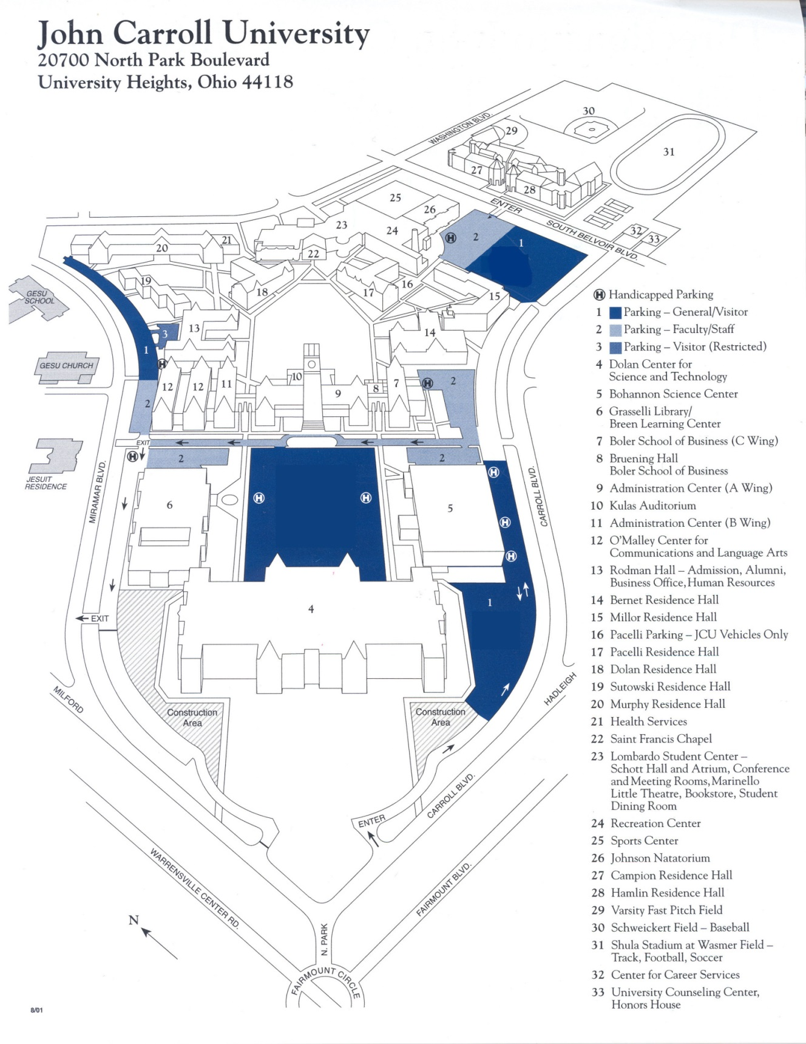

This map is old. The big blue parking lot in the middle of the page is now an intramural field.   The Bohannon Science Center (5) is now a parking lot. The “construction areas” are now parking lots. However, the O’Malley Center is still building 12.

Come in from Fairmount Circle, and go left as soon as you enter the campus. Park as closely as you can to building 12 and come inside.