Whitman Tournament (Feb 14-16) MORE LOGISTICS

Overview:

1. Rooms are very difficult here at Whitman—we don’t have many and they change a lot. What we have done is put together the room list for Friday rounds 1-3 and then Friday afternoon through the rest of the tournament. That information is detailed below. Please look at the round-by-round specifications. We are also using Prep rooms for debates so don’t leave anything behind.

2. Prep time. We are adding 6 minutes of prep time to the first three rounds ONLY. That will be reflected in the schedule. After round 3, we are back to twenty minutes of prep and just about everything will be in Olin.

3. Everything will be electronic—pairings, ballots, and results. If any of your judges have not sent in their current emails to Joe Gantt, please have them do so at [joe.gantt@gmail.com](mailto:joe.gantt@gmail.com). Getting on-line. It’s sporadic, but you should have some luck with the Whitman hotspot and it does not need a password. If that is not working for you and you want to connect to one of the secure Whitman servers, your username is: dcamp. The password for that is: Did44Fee8Say

4. Divisions. For the first half, we will be collapsing divisions with a JV break-out (of either finals, semis, or partial semis) that will start during the third elimination debate. For the second half, with more teams, we will keep the divisions separate. That will probably mean one less elim than is scheduled on Sunday and an earlier conclusion to the tournament.

5. Food. The tournament is not providing soda on tap. If you need a soda, there are lots of machines around. Please re-use your water bottle—we bought enough water bottles for one per person. Light breakfast and Full Lunch will be in Hunter lobby on Friday and Olin 1st floor on Saturday and Sunday. Friday’s dinner will be in the Cordiner Auditorium Foyer and Saturday’s will be in Olin.

6. While in the buildings:

** Keep the volume down

** Do not move furniture outside the rooms

** Rooms that are not scheduled probably have classes in them, especially Friday.

** Smokers—25 feet away from doors and dispose of trash in receptacles.

** Clean up after yourself

** Do not move the podiums in Olin 130 at all.

** The elevator in Olin in next to Olin #139 and there is a turn key to call the elevator.

**PREP ROOMS FOR ROUNDS 1-3 FRIDAY**

Maxey 121 University of Washington Bothell (2)

Maxey 204 University of Oregon (3)

Maxey 212 Boise State University (2)

Maxey 306 Western Washington University (7)

Maxey W33-Aud-N Western Washington University (7)

Olin 130 University of Montana (1)

Olin 223 (office) University Of Washington (1)Clark College (1)

Hunter 105: Clark College (1)

Hunter 205: TAB ROOM

Hunter 306/308: Whitman College (6)

Reid 110 (rnd 1) Reid G02 (rnd 2 and 3) Lewis & Clark College (5)

Reid 240 University of Puget Sound (4)

**COMPETITION ROOMS FOR Rounds 1-3 on FRIDAY**

DEBATE1 Maxey 121

DEBATE2 Maxey 204

DEBATE3 Maxey 212

DEBATE4 Maxey 306

DEBATE5 Maxey W33-Aud-N

DEBATE6 Olin 130

DEBATE7 Olin 223

DEBATE8 Hunter 105

Hunter 205 (TAB ROOM)

DEBATE9 Reid 110 (round 1), G02 for rounds 2 and 3

DEBATE10 Reid 240

DEBATE11 Jewett 110 W Lounge

DEBATE12 Jewett Red Room

DEBATE13 Jewett 210 W Lounge

DEBATE14 Jewett 310 W Lounge

DEBATE15 Jewett 333 E Lounge

DEBATE16 Jewett 410 W Lounge

DEBATE17 Jewett 435 E Lounge

**PREP ROOMS FOR the AFTERNOON on FRIDAY (round 4 on) and All Day Saturday / Sunday**

Olin 155: TAB ROOM

Olin 211: Bellevue College

Olin E115: Boise State University (2)

Olin E102: Clark College (1)

Olin 161: Lewis & Clark College (5)

Olin E123 University of Montana (1)

Olin E135: University of Oregon (3)

Olin 220: University of Washington Bothell (2)

Olin 246: University Of Washington (1)

Olin 247: University of Puget Sound (4)

Olin 157: Western Washington University (7)

Olin 130: Whitman College (6)

**COMPETITION ROOMS FOR the AFTERNOON on FRIDAY (round 4 on) and All Day Saturday / Sunday**

DEBATE1 Olin 130

DEBATE2 Olin 157

DEBATE3 Olin 161

DEBATE4 Olin 211

DEBATE5 Olin 220

DEBATE6 Olin 246

DEBATE7 Olin 247

DEBATE8 Olin 304

Hunter 205 BECOMES Olin 155 (TAB ROOM)

DEBATE9 Olin 305

DEBATE10 Olin 314

DEBATE11 Olin 315

DEBATE12 Olin 342

DEBATE13 Olin 343

DEBATE14 Olin E102

DEBATE15 Olin E115

DEBATE16 Olin E123

DEBATE17 Olin E135

DEBATE 18 Olin 160

DEBATE 19 Olin 312

DEBATE 20

## UPDATED SCHEDULE

**Thursday, Feb 13**

Registration, 7-9pm, Hunter Lobby

**Friday, Feb. 14**

7:15- 8:00 Light breakfast, Late Registration, Hunter Lobby

8:15 Round 1 (26 minutes prep time)

10:00 Round 2 (26 minutes prep time)

11:50 Lunch provided, Hunter Lobby

12:45 Round 3 (26 minutes prep time)

2:15 Round 4 (**20** minutes prep time for this round and every subsequent round)

4:30 Round 5

5:45 Dinner provided / Ethics and Equity Forum in Cordiner Hall Auditorium

7:30 Elim 1

**Saturday, Feb. 15**

8:15 Elim 2

10:15 Elim 3 (1st JV Break-out)

12:00 Lunch provided, Olin

12:45 Elim 4 (2nd JV Break-out)

2:30 Elim 5

4:15 Round 1

6:00 Awards / Dinner provided, Olin

7:00 Round 2

8:45 Round 3

**Sunday, Feb. 16**

8:30 Round 4

10:15 Round 5

12:00 Lunch provided / Awards

12:45 Elim 1

2:15 Elim 2

4:30 Elim 3

6:00 Elim 4

7:30 Elim 5

### MAPS

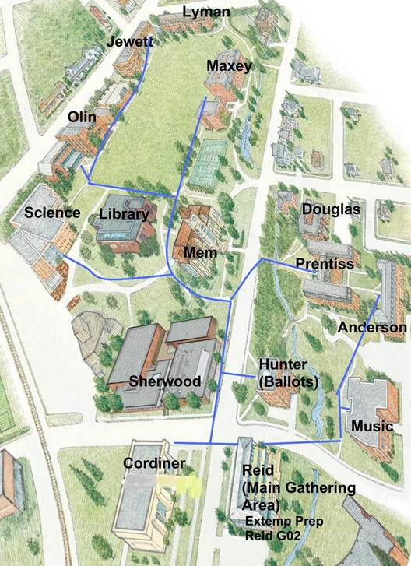

Full Campus Map: <http://www.whitman.edu/Documents/About%20Whitman/CampusMap.pdf>

Google Map: <http://www.whitman.edu/content/apsnw/whitman-college-maps,-campus>