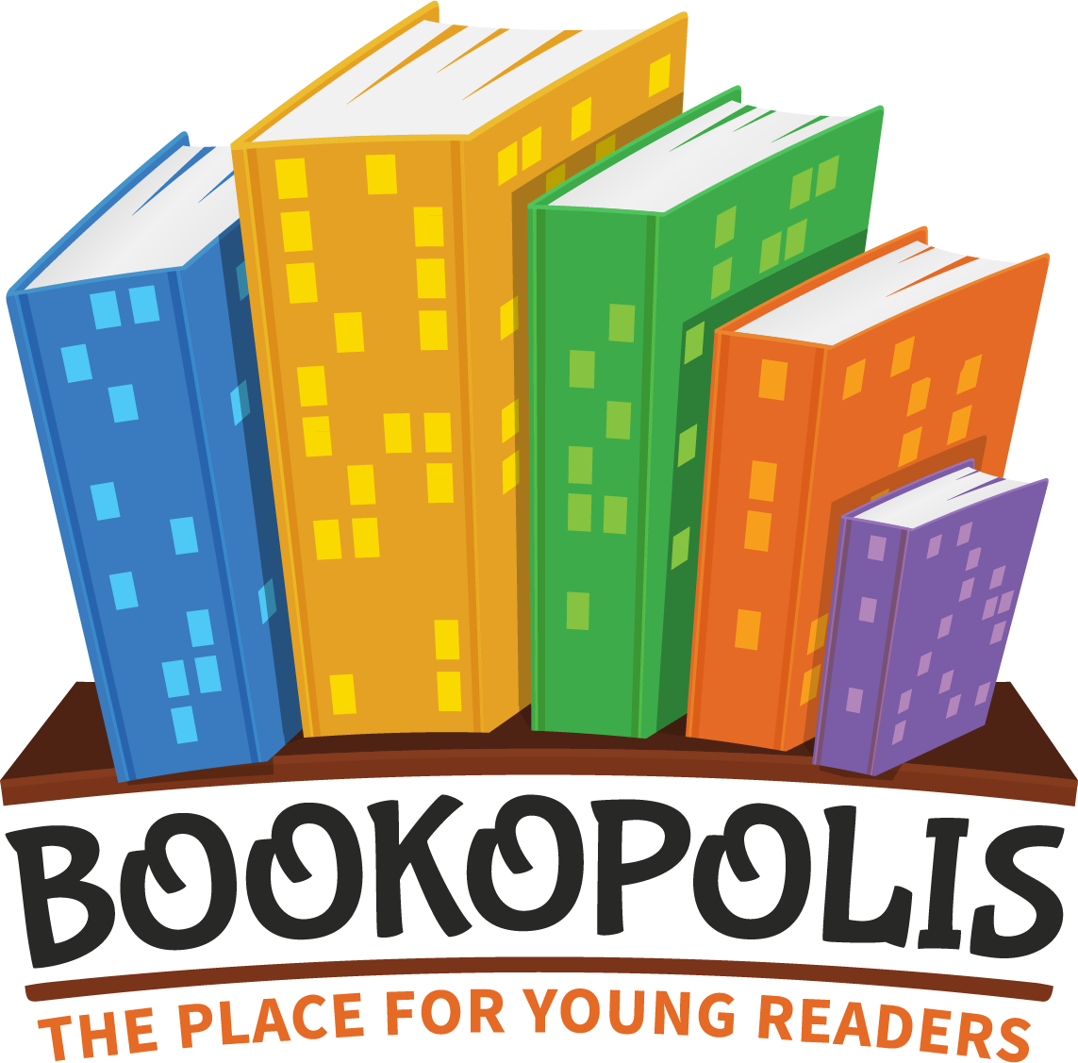 READER INTEREST INVENTORY
Student Name: ____________________________________________ Grade: ___________

1. Name the last 3 books you read and say if you liked them or not.

2. Name ONE book (or series) that you would take on a month long trip.

3. What is your favorite… Movie? Show? YouTube channel?

4. What video games or apps (if any) do you like to play?

5. What is your favorite and least favorite subject at school?

6. What hobbies or activities do you like to do outside of school?

7. Circle the formats you like to read. Cross out ones you do no (or think you don’t like.)
Prose (Novel) Verse Novel Graphic Novel How-To/Fact Books Short Story

8. Circle all the GENRES you like. Cross out ones you do not (or think you do not) like.
Realistic Historical Mystery Fantasy Adventure Nonfiction Mythology

9. How many books do you have at home?
0-10 11-20 21-30 31-50 > 50

10. Do you prefer to read physical books or eBooks (Kindle, etc.)?

11. On a scale of 1 to 5 (1=low and 5=high), how much do you like to read?

- 2 3 4 5

