A Brief Update of News Around Arizona
June 2018
The Arizona Office of Tourism is pleased to provide this monthly update of new and noteworthy items regarding Arizona’s tourism industry. For more information, contact Becky Blaine at bblaine@tourism.az.gov, Kim Todd at ktodd@tourism.az.gov or Marjorie Magnusson at mmagnusson@tourism.az.gov.

Hotel News

The Tavern Hotel in Cottonwood has Expanded
The Tavern Hotel which originally had 10 rooms has grown to a total of 41 rooms and two luxury penthouses. One penthouse is located above the Tavern Grille, the other above Pizzeria Bocce. To go along with the additional accommodations, the Tavern has put together a series of packages geared toward active guests. These are one-and two-night stays that offer recreational opportunities throughout the region. The hotel also includes 24-hour front desk service, making it easier for guests to check in at any time. Accommodations at the Tavern Hotel feature one king bed or two queen beds, flat-screen televisions and free Wi-Fi. A continental breakfast is included for guests across Main Street at Crema Craft Kitchen & Bar. The hotel was originally built in 1925 as a grocery store and was a center of activity in Old Town Cottonwood. The historic building was preserved and the hotel was completed in 2011.The Tavern Hotel is located 90 minutes north of Phoenix and just minutes from Sedona to the east and Jerome to the west.

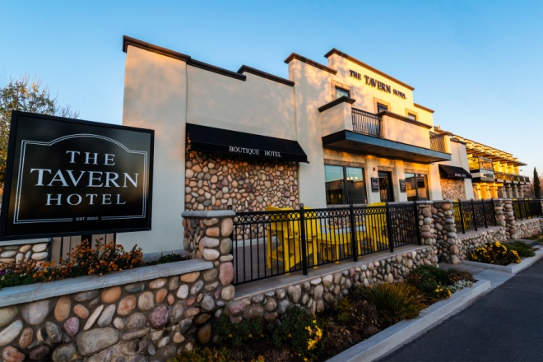

The Tavern Hotel

Hampton Inn & Suites Phoenix Downtown Now Open
The new Hampton Inn and Suites Phoenix Downtown is now open in downtown Phoenix. The new property is located within walking distance to the ASU downtown campus, Phoenix Convention Center, CityScape, Talking Stick Resort Arena and Chase Field. Every room offers a 50-inch HDTV, mini-refrigerator, coffeemaker, and desk with ergonomic chair. In addition, the property features the Forever Young room design by Hilton Hotels and the first Hampton Inn Lobby Bar located in the Perfect Mix Lobby. Hampton Inn and Suites offers free Wi-Fi, business services, fitness center and free breakfast.

Hampton Inn & Suites

Aloft Hotel Breaks Ground at Westgate Entertainment District
Arizona’s newest Aloft Hotel will be located at the corner of 91st and Glendale avenues in Glendale, AZ. The 2.4-acre property is adjacent to the Westgate Entertainment District and will have 100 guestrooms. The mixed-use Westgate Entertainment District is anchored by AMC Theaters, Dave & Busters and is adjacent to Tanger Outlets. Westgate is next to the Gila River Arena, home of the Arizona Coyotes, and adjacent to the University of Phoenix Stadium, home to the Arizona Cardinals. Aloft Hotels owned by Starwood Hotels & Resorts was created in 2005 and offers guests an urban, modern design. Aloft Hotel will be the eighth hotel within a mile of University of Phoenix Stadium and add to the 1,605 hotel rooms within the city. The property is expected to be completed by January 2019.

Aloft Hotel

Attractions

New Glamping Vacations Offered at Lake Powell
Aramark, the authorized concessionaire at Lake Powell, has partnered with recreational vehicle company Airstream to bring new glamping rental options to Lake Powell Resort in Page, Arizona. Aramark has begun taking reservations for the three Airstreams at Wahweap Campground. The brand new 30-foot Airstream International Signature travel trailers are situated in full hookup RV campsites. Custom-designed features include natural wood flooring, handcrafted Italian cabinetry, Grohe faucets, porcelain toilets, kitchen appliances and stainless steel sinks. At Lake Powell, the second largest man-made lake in the U.S., glamping vacationers are in close proximity to lake activities including powerboat and personal watercraft rentals, hiking to Horseshoe Bend or enjoying a tour of Antelope Canyon.

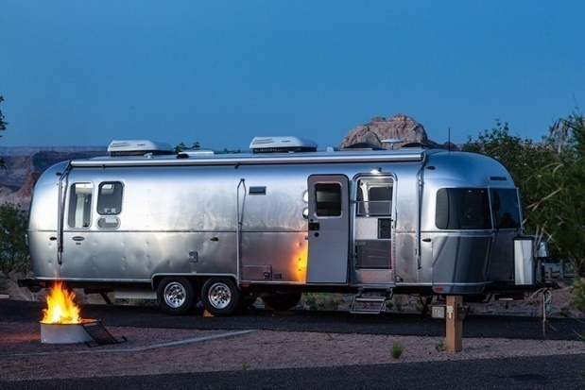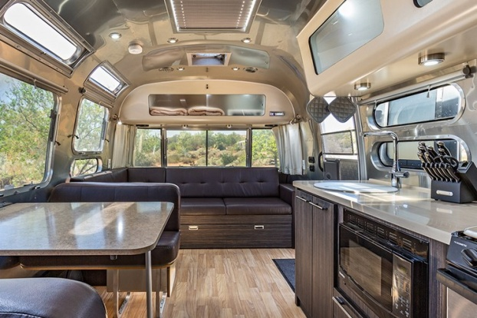
Glamping at Lake Powell

Tucson Completes “The Loop” Bike Path
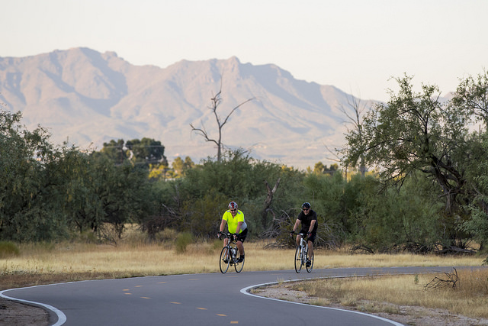
Tucson celebrated the completion of The Loop, a 131-mile system of paved, shared-use paths and short segments of buffered multi-use bike lanes. The new bike path allows cyclists, pedestrians, joggers and equestrians an opportunity to enjoy the Sonoran Desert on vehicle-free pathways. The Loop connects parks, trailheads, bus and bike routes, workplaces, restaurants, hotels and motels, shopping and entertainment areas. In addition to Tucson, the Loop extends through unincorporated Pima County, Marana, Oro Valley, Tucson, and South Tucson. The connections are the result of Pima County's cooperative partnerships with these jurisdictions. The Loop

Adventure

Papillon Group Announces Return of Several Popular Tours for Summer 2018
Papillon Group announced the return of several popular tours for the summer travel season. The Whitewater Rafting tour flies guests to Peach Springs, Arizona from Las Vegas, Nevada, where Hualapai River Runners provide a guided eight-person motorized river raft, specifically designed for traversing the Colorado River. Each raft will make a stop along the river bank for passengers to enjoy a hike and lunch. The concluding helicopter flight will soar along canyon cliffs while ascending 4,000 feet out of the canyon to the Grand Canyon West Airport. The Scenic Canyon River Adventure pairs a sightseeing airplane tour with a day of rafting on the Colorado River through Glen Canyon. The tour begins with a scenic flight from the Grand Canyon South Rim to Page, Arizona, with aerial sights of the Grand Canyon's Eastern Rim, the confluence of the Little Colorado River, Horseshoe Bend and Lake Powell. Guests also experience Antelope Canyon and learn about the history of the slot canyon and Navajo lands. The tour continues with Wilderness River Adventures aboard a motorized raft that takes guests up a 15.5-mile stretch of the Colorado River. Finally, the Canyon Smooth Water Bus Trip option trades the airplane for ground transportation. This 15.5-mile float trip between Glen Canyon and Horseshoe Bend includes a boxed lunch for each participant to enjoy at their leisure during their trip. The river eventually carries guests to historic Lee's Ferry, where the raft tour concludes. These tours are available now through October 31.

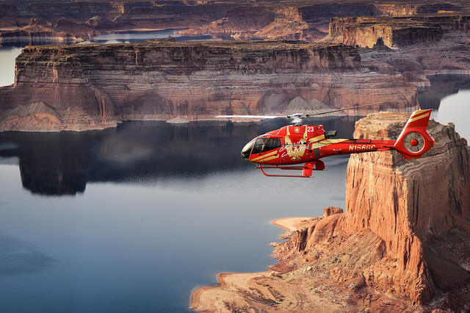
Papillon Group

Connect:
@arizonatravel
@visit_arizona
www.youtube.com/user/ArizonaTourism
Newsroom: http://newsroom.visitarizona.com/
Official State Visitors Guide: http://www.visitarizona.com/visitors-guide
Additional inspiration: http://www.visitarizona.com/planning/local-word

